**Lab Title**

**LAB #** **XX**

**Fall 2019**

**CSE208L Object Oriented Programming Lab**

Submitted by: **Student Name**

Registration No. : **18PWCSE16XX**

Class Section: **A/B/C**

“On my honor, as student of University of Engineering and Technology, I have neither given nor received unauthorized assistance on this academic work.”

Student Signature: ______________

Submitted to:

**Engr. Sumayyea Salahuddin**

October 9, 2019

Department of Computer Systems Engineering

University of Engineering and Technology, Peshawar

**Objectives of the Lab:**

Objectives of the lab are to:

# Clearly understand the purpose and advantages of OOP

# Understand the concept of a Class and Objects

# Develop a basic class containing Data Members and Member Functions

# Use access specifiers to access Class Members

# Make Simple and Overloaded Constructor

# Use the Class Objects and Member Functions to provide and extract data from Object

# Practice with Classes and Objects

# Activity # 01

**Title:**

Make a class for heater and model it using temperature.

**Problem analysis:**

Create a class, **Heater** that contains a single integer field, **temperature**. Define a constructor that takes no parameters. The **temperature** field should be set to the value 15 in the constructor. Define the mutators **warmer** and **cooler**, whose effect is to increase or decrease the value of the temperature by 5 respectively. Define an accessor method to return the value of **temperature**. Demonstrate the use of Heater class.

**Algorithm:**

UML diagram for the above problem is given below:

* 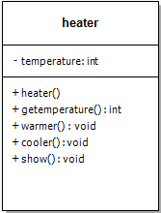First make class heater
* Declare temperature as private integer field
* Define no argument constructor to set value of temperature to 15
* Define gettemperature method to return value of temperature
* Define warmer and cooler method to increase and decrease temperature by 5 respectively
* Define show function to display the output
* In main function, make objects of heater to demonstrate theeuse of heater
* Call each function one after the other and display the show function as shown in the flow chart.

**Flowchart:**

Start

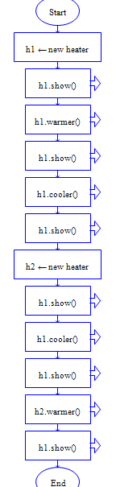

Private: int temperature

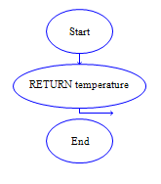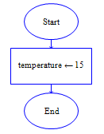

Int gettemperature()

heater()

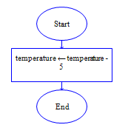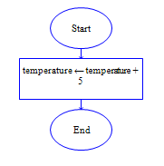

Void cooler()

void warmer()

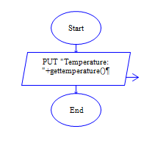

void show()

End

**In C++**

**Source code: Output:**

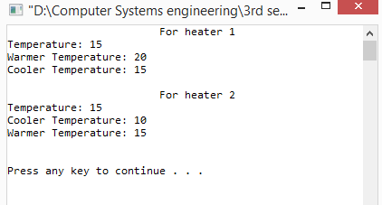

**In Python**

**Source code: Output:**

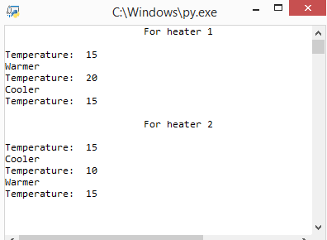

**In Java (Optional)**

**Source code:**

**Output:**

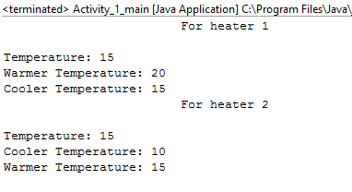

**Conclusion:**

This program helps us in understanding the basic concepts of classes and objects in different languages. It acts as a base for us and helps us in preparing ourselves for the higher level of programming. We get to know about the constructor and method in OOP with the help of this program.

PLACE LAB RUBRICS HERE.